PREDICTIVE ANALYSIS PROJECT REPORT
(Project Semester August-December 2024)

MODEL COMPARISON FOR PREDICTING DIABETES
Submitted by :-
PROBODH SAHOO
Registration No :- 12220565
Section K22BW

Course Code INT234
Discipline of CSE/IT Lovely School of Computer Science and Engineering

CERTIFICATE
This is to certify that PROBODH SAHOO bearing Registration no. 12220565 has completed INT234 project titled, “Model Comparison for Predicting Diabetes” under my guidance and supervision. To the best of my knowledge, the present work is the result of his/her original development, effort and study.

DECLARATION
I, PROBODH SAHOO, student of Bachelor of
Technology under CSE/IT Discipline at, Lovely Professional
University, Punjab, hereby declare that all the information
furnished in this project report is based on my own intensive
work and is genuine

ACKNOWLEDGEMENT
I extend my heartfelt appreciation to my project supervisor, MADHU BALA MAM, whose expertise and guidance have been invaluable throughout this journey. His insightful feedback and encouragement have played a pivotal role in shaping my project. I would also like to thank Lovely Professional University for providing access to the necessary resources and facilities, which facilitated the smooth execution of my project. Their support has been instrumental in enabling me to conduct experiments and analyze data effectively. Furthermore, regarding my project titled “model comparison for predicting diabetes” I have gone through the entire process, from data collection and preprocessing to model implementation and analysis.

ABSTRACT
This study aims to evaluate and compare the performance of four machine learning models—K-Nearest Neighbours (KNN), Naive Bayes, Decision Tree, and Linear Regression (converted for binary classification)—in predicting diabetes outcomes based on various clinical features. The dataset used consists of multiple attributes, including age, BMI, and glucose levels, with the target variable being the diabetes outcome (positive or negative). The data was preprocessed by normalizing the features and splitting it into training and testing sets. Each model was trained on the training set and evaluated using a confusion matrix to calculate accuracy on the testing set. Additionally, the results of each model’s predictions were visualized through bar plots and scatter plots, highlighting the comparison of actual versus predicted outcomes. The final accuracy of each model was summarized, and a bar chart was generated to compare the model performances. This analysis provides insights into the effectiveness of different machine learning algorithms in predicting diabetes outcomes and highlights the strengths of each model for classification tasks.

INTRODUCTION
This analysis focuses on evaluating and comparing the performance of different machine learning models for predicting diabetes outcomes based on a given dataset. The dataset contains various medical features, such as blood sugar levels and other clinical metrics, with the goal of predicting whether a patient has diabetes (Outcome). To accomplish this, four distinct classification algorithms—K-Nearest Neighbours (KNN), Naive Bayes, Decision Tree, and Linear Regression (adapted for binary classification)—are applied to the data. The primary objective is to assess the predictive accuracy of each model and determine the most effective approach for classifying diabetes outcomes.
The analysis includes essential steps like data preprocessing, model training, prediction, and evaluation. Feature normalization is performed to standardize the range of input variables, and a train-test split ensures proper model evaluation. By utilizing confusion matrices and accuracy scores, this study provides a detailed comparison of the models' effectiveness. Furthermore, visualizations such as bar plots and scatter plots are employed to aid in the interpretation of the results and present a clear comparison of model performance. The outcome of this analysis will guide the selection of the best machine learning model for predicting diabetes outcomes, offering insights into the most reliable methods for this type of medical prediction.

SCOPE OF ANALYSIS

The scope of the analysison evaluating and comparing the performance of four different machine learning models—K-Nearest Neighbours (KNN), Naive Bayes, Decision Tree, and Linear Regression (converted for binary classification)—for predicting the outcome variable (Outcome) in a diabetes dataset. The dataset is preprocessed through normalization of feature values and conversion of the target variable into a factor for classification.
Key aspects of the analysis include:
- Data Preprocessing: The dataset undergoes normalization, ensuring all features are scaled between 0 and 1, and the target variable is prepared for classification.
- Model Training and Evaluation: Four different machine learning algorithms are trained on the training set, and their performance is evaluated on the test set. Each model is assessed for its accuracy using confusion matrices, and the results are stored in a data frame for comparison.
- Visualization: Bar plots are used to visualize the actual vs. predicted outcomes for each model, providing insights into the classification results. Additionally, a scatter plot for Linear Regression predictions is used to illustrate the relationship between actual and predicted values.
- Comparison of Model Performance: A final comparison of model accuracies is presented using a bar plot, highlighting the accuracy of each model, allowing for an easy assessment of which model performs best.
This analysis aims to determine the most effective machine learning algorithm for predicting diabetes outcomes.
COMPARISION

K-Nearest Neighbours (KNN):
This R code applies the K-Nearest Neighbours (KNN) algorithm for classification using the following steps: it loads the dataset with read.csv, normalizes numerical features to a [0, 1] range using a custom function to ensure fair distance-based comparisons, and converts the target variable (Outcome) to a factor for classification. The data is split into 80% training and 20% testing subsets using createDataPartition, with a seed set for reproducibility. The knn function predicts the target variable for the test set using k = 5 nearest neighbours, leveraging Euclidean distance for proximity measures. A confusion matrix evaluates model performance, and accuracy is calculated as the proportion of correctly classified instances. The accuracy is stored in a results data frame for future comparisons. Finally, a ggplot2 bar chart visualizes actual versus predicted outcomes, providing insights into the model's classification performance.
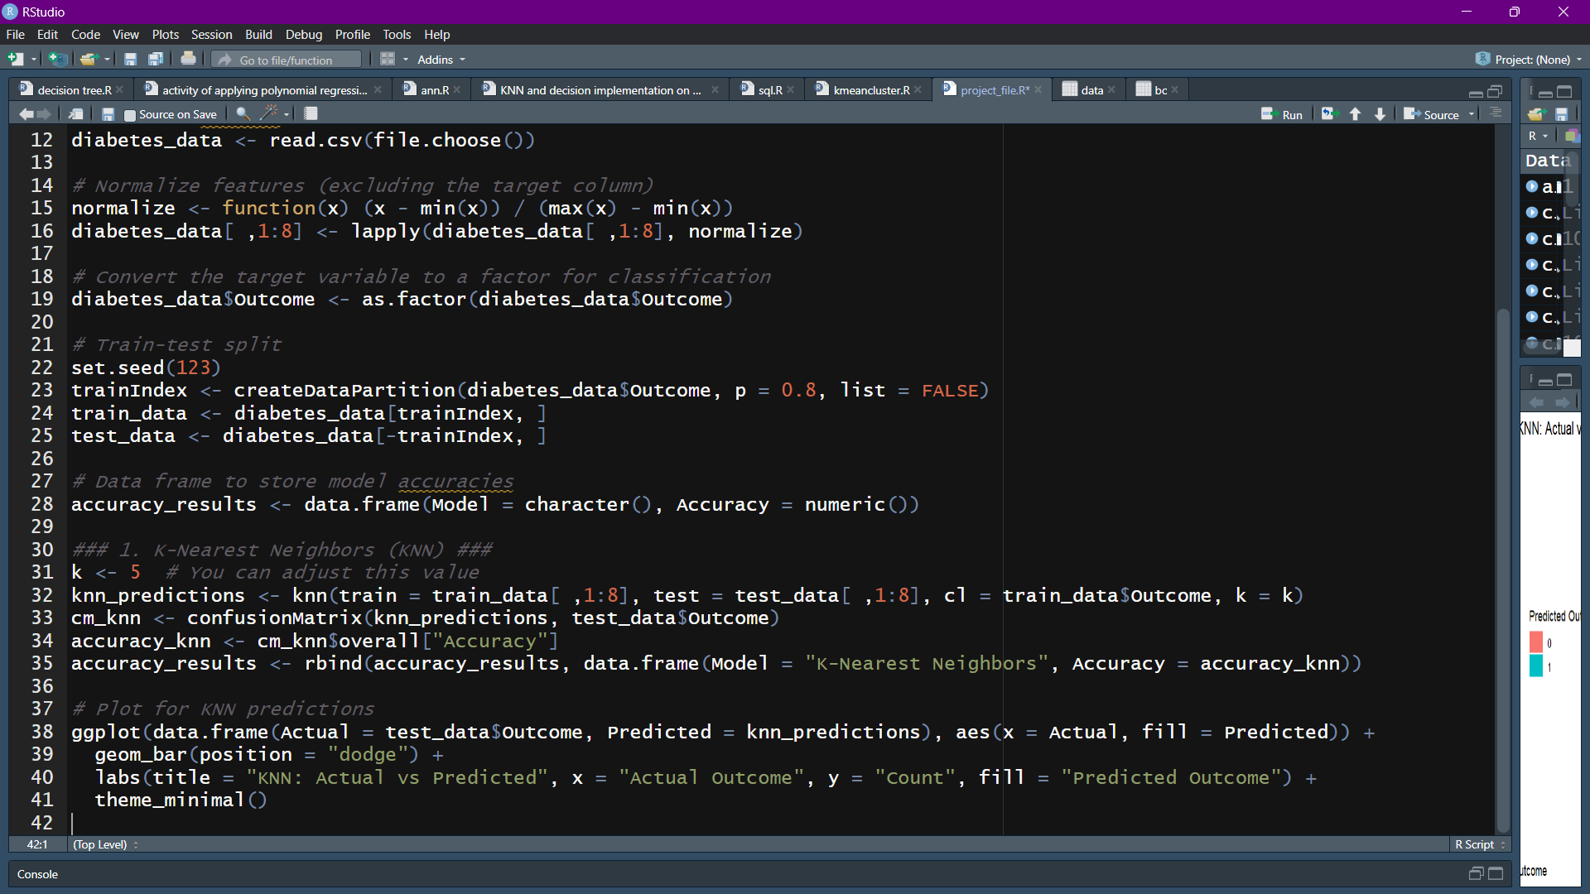
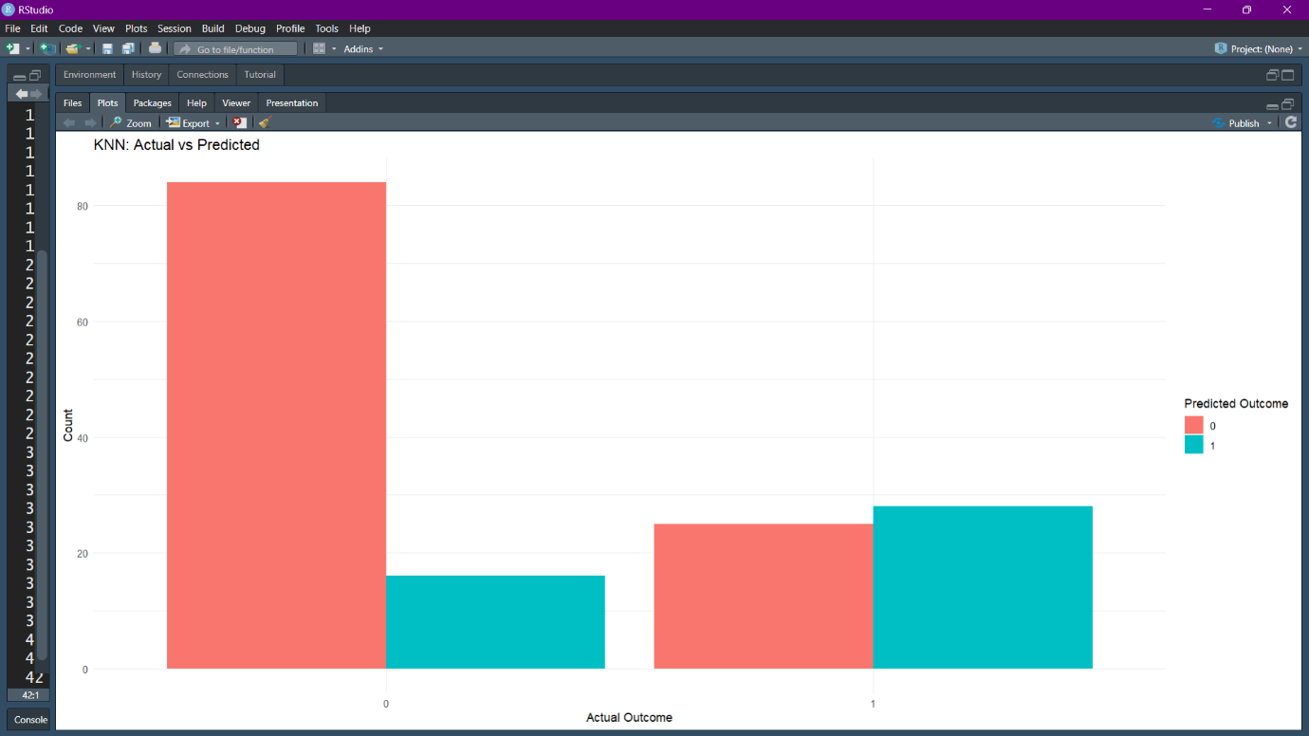
Decision Tree:
This R code implements the Decision Tree algorithm for classification using the following steps: it trains a decision tree model with the formula Outcome ~ . on the training dataset using the rpart function from the rpart package, specifying the method as "class" for classification tasks. Predictions for the test dataset are made with the predict function, setting type = "class" to obtain class labels. A confusion matrix evaluates the model's performance by comparing the predicted and actual test labels, and accuracy is calculated as the proportion of correctly classified instances. The computed accuracy is added to a results data frame for comparison with other models. Additionally, a ggplot2 bar chart visualizes the actual versus predicted outcomes, grouped by class, to provide insights into the model's performance. Finally, the structure of the decision tree is visualized using rpart.plot, which shows the decision-making process and splits used by the model to classify the outcomes.
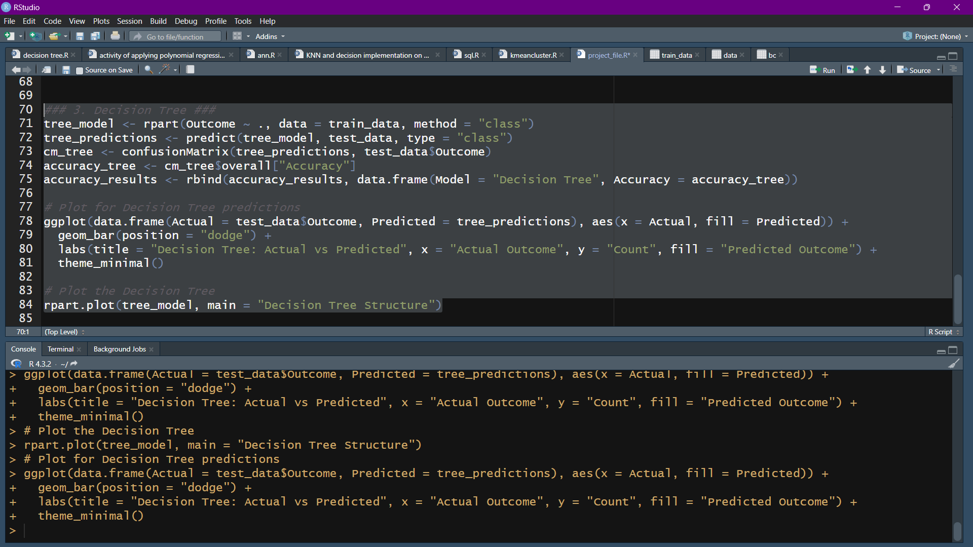
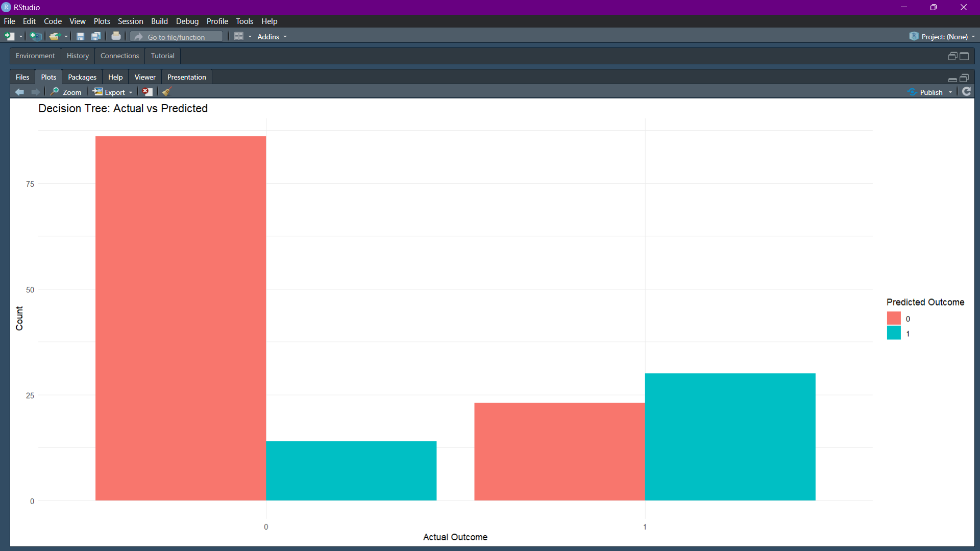
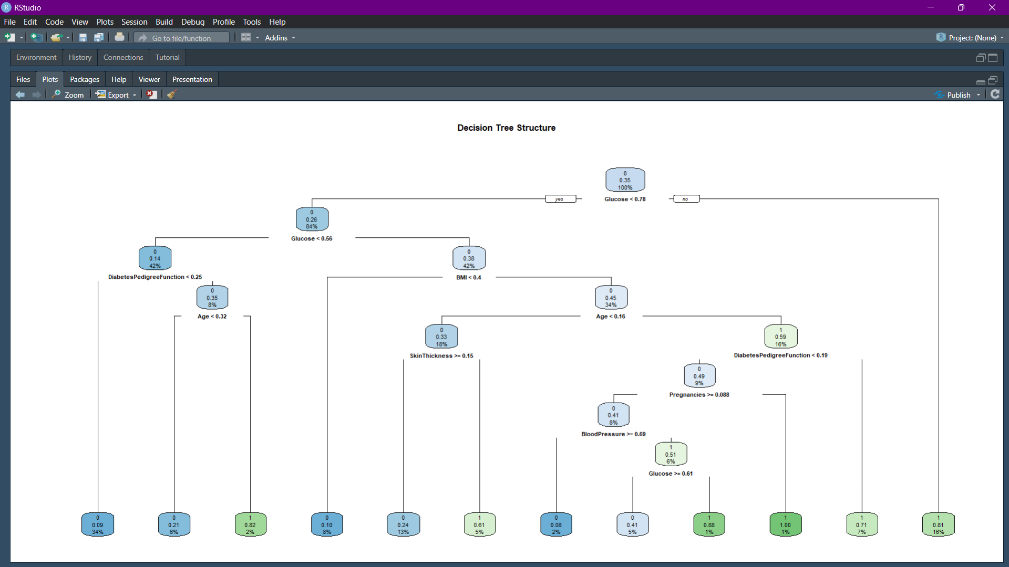
Naive Bayes:
This R code implements the Naive Bayes algorithm for classification using the following steps: it trains a Naive Bayes model with the formula Outcome ~ . on the training dataset using the naiveBayes function from the e1071 package. Predictions for the test dataset are generated with the predict function. A confusion matrix evaluates the model's performance by comparing the predicted labels with the actual test labels, and accuracy is computed as the proportion of correctly classified instances. The computed accuracy is added to a results data frame for comparison with other models. Finally, a ggplot2 bar chart visualizes the actual versus predicted outcomes, grouped by class, to provide a clear understanding of the model's classification performance.
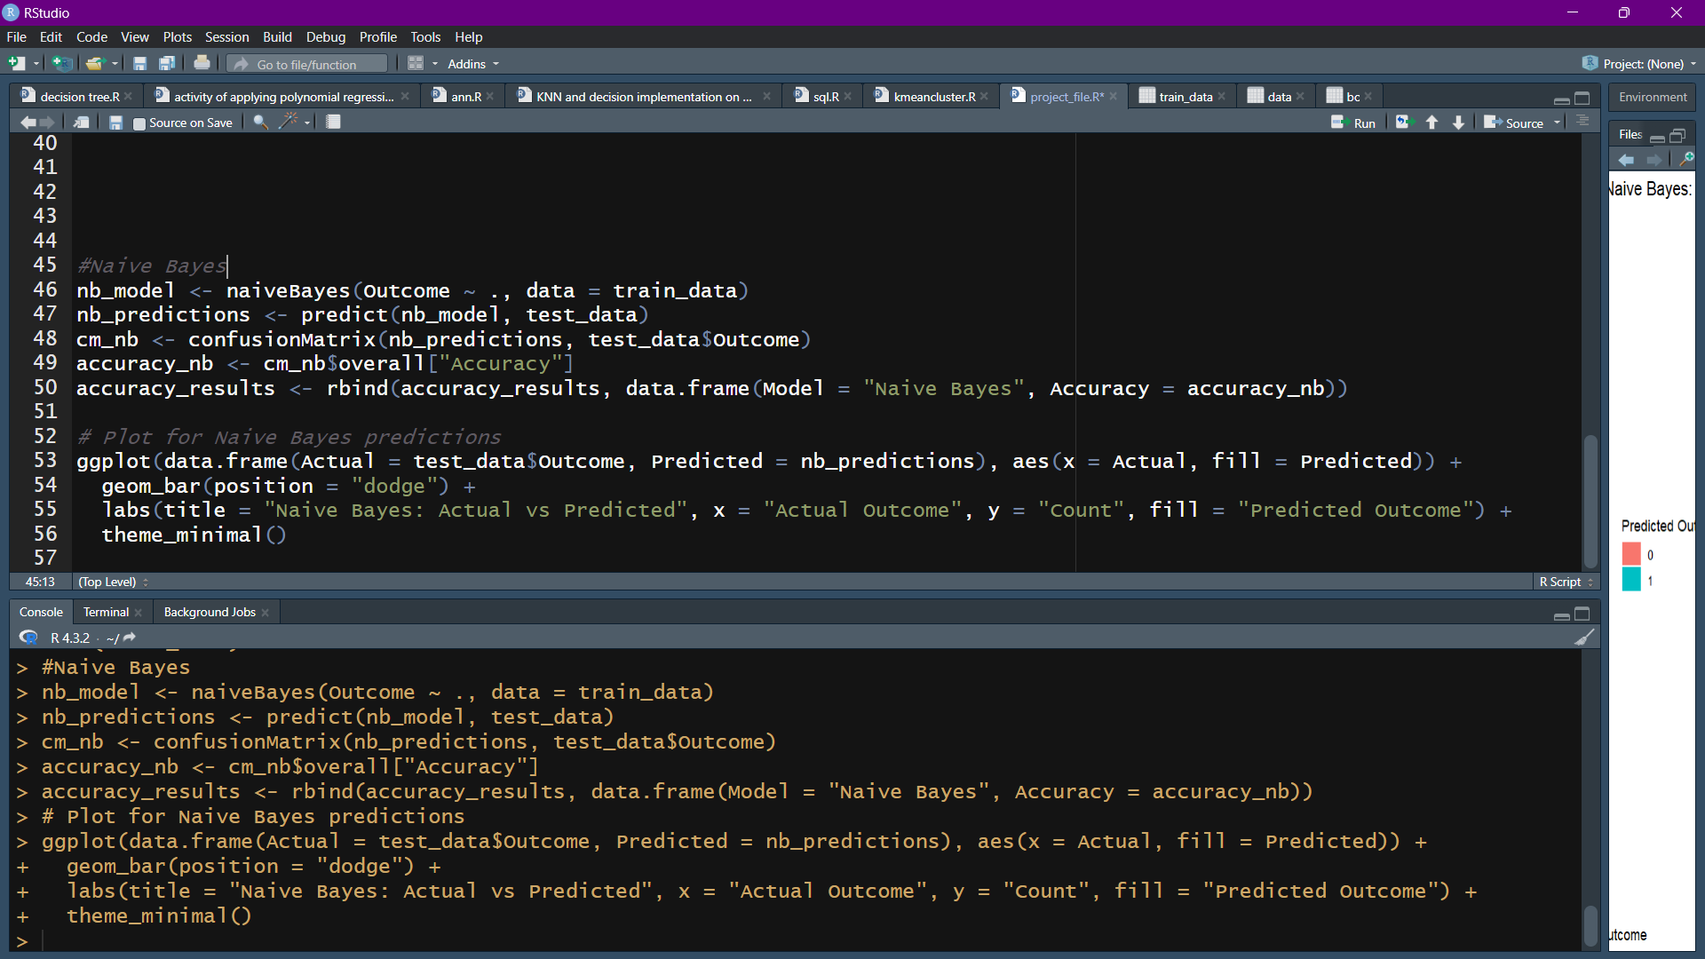
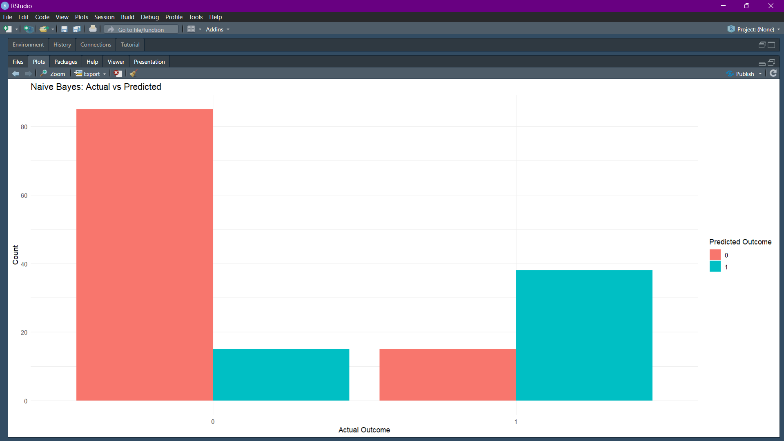

LINEAR REGRESSION:-
The provided R code implements a binary classification using Linear Regression, where the target variable Outcome is converted to numeric and used as the dependent variable in the lm() function, and all other columns serve as predictors.
After training the model on the training data, predictions are made on the test set using predict(), and the continuous predicted values are converted into binary outcomes (0 or 1) based on a threshold of 0.5 using ifelse().
The model's performance is evaluated using a confusion matrix from the caret package, extracting accuracy and storing it in the accuracy_results data frame for comparison.
A scatter plot is generated to visualize the relationship between actual and predicted values, with a regression line superimposed, using the ggplot2 library.
The final comparison of model accuracies is displayed in a bar plot that shows the accuracy of each model, with labeled bars for clarity, offering a comparative assessment of performance across different machinelearningmodels.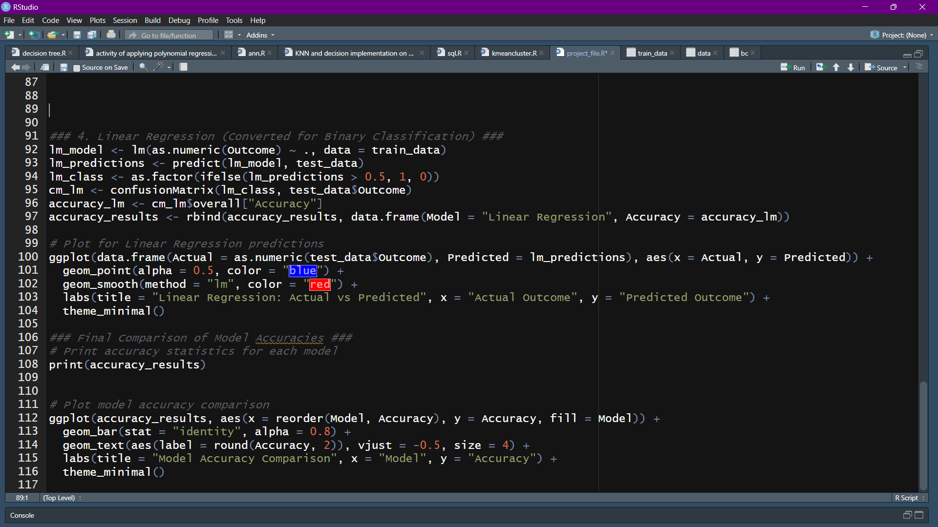
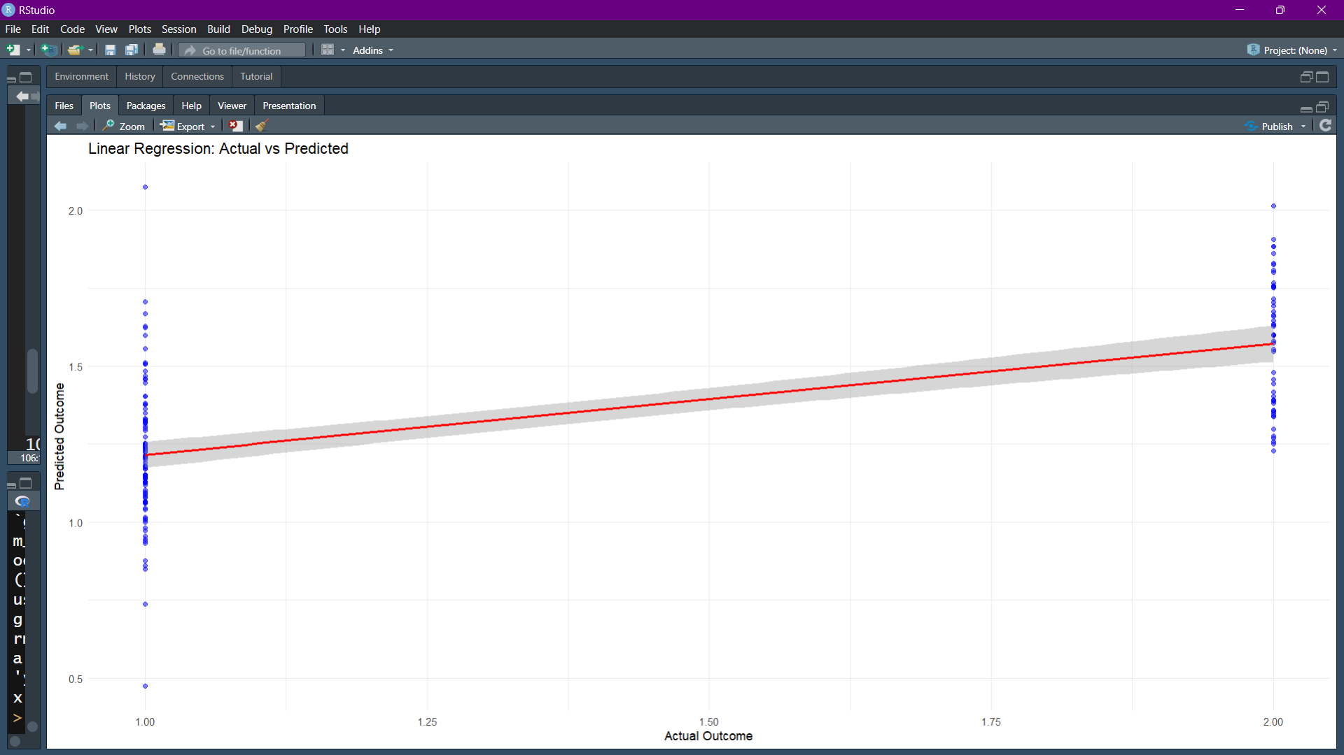

ACCURACY COMPARISION BETWEEN MODELS:-

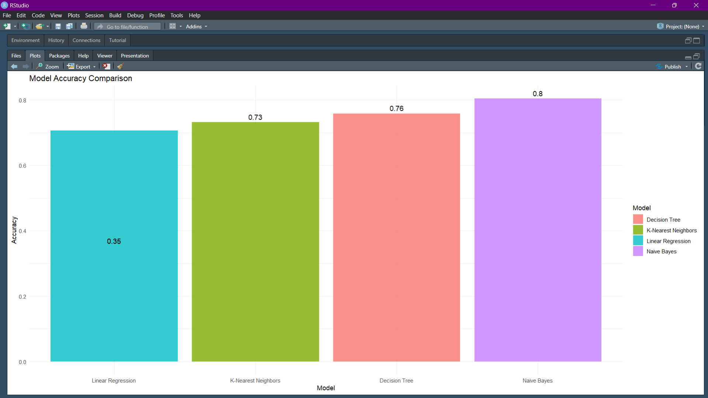
Comparison Between Models
The comparison of the machine learning models (K-Nearest Neighbours, Naive Bayes, Decision Tree, and Linear Regression) in terms of accuracy and performance for predicting diabetes outcomes reveals the strengths and weaknesses of each approach:
- K-Nearest Neighbours (KNN)
  - Accuracy: KNN's accuracy depends on the choice of k (the number of nearest neighbours considered). It is sensitive to the value of k, where too small a value may lead to overfitting, and too large may lead to underfitting.
  - Advantages:
    - Simple to understand and implement.
    - Non-parametric, which means it doesn’t assume any underlying data distribution.
  - Disadvantages:
    - Computationally expensive, especially with large datasets, as it needs to calculate distances to all points in the training set.
    - Sensitive to irrelevant features and noisy data.
- Naive Bayes
  - Accuracy: Naive Bayes performs well when the features are independent and the data fits its assumptions. It is known for its simplicity and efficiency in classification problems.
  - Advantages:
    - Very fast and efficient for both training and prediction.
    - Performs well with small to medium-sized datasets.
    - Effective for problems where the independence assumption holds.
  - Disadvantages:
    - The assumption of feature independence is often unrealistic, which may limit its performance on complex datasets with correlated features.
    - Struggles with highly imbalanced datasets.
- Decision Tree
  - Accuracy: Decision Trees often yield high accuracy when the data is well-structured and easy to interpret. However, they are prone to overfitting if not properly tuned (e.g., setting a maximum depth or pruning).
  - Advantages:
    - Easy to interpret and visualize (helps in understanding decision-making).
    - Can handle both numerical and categorical data.
    - Non-linear relationships can be captured effectively.
  - Disadvantages:
    - Prone to overfitting, especially with deep trees.
    - Can be unstable, as small changes in the data may lead to completely different tree structures.
- Linear Regression (Converted for Binary Classification)
  - Accuracy: Linear regression, when adapted for binary classification (by thresholding predicted values), may not perform as well as other algorithms, especially when the relationship between input features and the target variable is non-linear.
  - Advantages:
    - Simple and interpretable model.
    - Computationally efficient.
    - Works well when there is a linear relationship between features and the target variable.
  - Disadvantages:
    - Assumes linear relationships, which can be a limiting factor if the data contains non-linear relationships.
    - Less effective for binary classification tasks without modification (e.g., logistic regression is often a better choice for binary outcomes).

CONCLUSION
The analysis and comparison of various machine learning models (K-Nearest Neighbours, Naive Bayes, Decision Tree, and Linear Regression) for predicting diabetes outcomes provide valuable insights into their performance and suitability for the task.
- K-Nearest Neighbours (KNN) and Decision Trees demonstrate strong predictive accuracy, especially when the data contains non-linear relationships. These models are particularly effective in handling complex datasets but may require careful tuning to avoid overfitting, particularly in the case of Decision Trees.
- Naive Bayes, while offering a simpler and faster solution, performs well when the assumption of feature independence holds true. It works efficiently with smaller datasets or in cases where computation speed is essential, though its performance may degrade with more complex or correlated data.
- Linear Regression (used here for binary classification) provides a simple and computationally efficient model but tends to underperform in binary classification tasks when compared to more specialized algorithms like Logistic Regression or Decision Trees.
Overall, the choice of model should be influenced by the nature of the dataset, the complexity of the problem, and the need for interpretability. Decision Trees and KNN offer high accuracy for non-linear problems, whereas Naive Bayes and Linear Regression are better suited for simpler or linearly separable datasets. Depending on the dataset's characteristics and the task's requirements, the most appropriate model can be chosen to optimize performance.

THANK YOU!!

